**WEEK 6 SOLUTONS**

**Exercise 2:** Create a react app for Student Management Portal named StudentApp and create a component named Home which will display the Message “Welcome to the Home page of Student Management Portal”. Create another component named About and display the Message “Welcome to the About page of the Student Management Portal”. Create a third component named Contact and display the Message “Welcome to the Contact page of the Student Management Portal”. Call all the three components.

Steps:

1. Creating the App: student-app:

npx create-react-app student-app

cd student-app

npm install react-router-dom

1. File Structure:

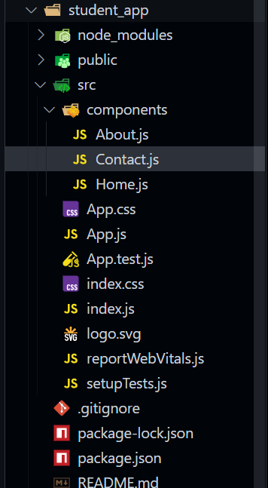

1. Code for Components:

***Home.js:***

import React from "react";

const Home = () => (

  <h2>Welcome to the Home page of Student Management Portal</h2>

);

export default Home;

**About.js**

import React from "react";

const About = () => (

  <h2>Welcome to the About page of Student Management Portal</h2>

);

export default Home;

**Contact.js**

import React from "react";

const Contact= () => (

  <h2>Welcome to the Contact page of Student Management Portal</h2>

);

export default Home;

1. Editing the App.js

**App.js:**

import React from "react";

import { BrowserRouter as Router, Routes, Route, Link } from "react-router-dom";

import Home from "./components/Home";

import About from "./components/About";

import Contact from "./components/Contact";

function App() {

  return (

    <Router>

      <div style={{ padding: "20px" }}>

        <h1>StudentApp</h1>

        <nav>

          <ul

            style={{

              display: "flex",

              gap: "20px",

              listStyleType: "none",

              paddingLeft: 0,

            }}

          >

            <li>

              <Link to="/">Home</Link>

            </li>

            <li>

              <Link to="/about">About</Link>

            </li>

            <li>

              <Link to="/contact">Contact</Link>

            </li>

          </ul>

        </nav>

        <hr />

        <Routes>

          <Route path="/" element={<Home />} />

          <Route path="/about" element={<About />} />

          <Route path="/contact" element={<Contact />} />

        </Routes>

      </div>

    </Router>

  );

}

export default App;

1. Starting the App: npm start